TASK 1
INCLUDE Irvine32.inc

.data
promptX BYTE "Enter X coordinate (0-70): ", 0
promptY BYTE "Enter Y coordinate (0-20): ", 0
star BYTE "*", 0
xCoord DWORD ?
yCoord DWORD ?

.code
main PROC

mov edx, OFFSET promptX

call WriteString
call ReadDec
mov xCoord, eax

mov edx, OFFSET promptY
call WriteString
call ReadDec

mov yCoord, eax

call Clrscr

mov dh, BYTE PTR yCoord
mov dl, BYTE PTR xCoord

call Gotoxy

mov edx, OFFSET star
call WriteString

mov dh, 24
mov dl, 0

call Gotoxy

call WaitMsg

exit
main ENDP

END main
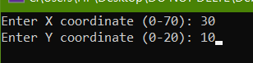


TASK 2

INCLUDE Irvine32.inc

.data
star BYTE "*", 0
msg1 BYTE "Enter X 0-70: ", 0
msg2 BYTE "Enter Y 0-20: ", 0
msg3 BYTE "Enter foreground color 0-15: ", 0
msg4 BYTE "Enter background color 0-15: ", 0

.code
main PROC
mov edx, OFFSET msg1
call WriteString
call ReadInt
mov ebx, eax

mov edx, OFFSET msg2
call WriteString
call ReadInt
mov ecx, eax

mov edx, OFFSET msg3
call WriteString
call ReadInt
mov edi, eax

mov edx, OFFSET msg4
call WriteString
call ReadInt

imul eax, 16
add eax, edi
call SetTextColor

call Clrscr

mov dh, cl
mov dl, bl
call Gotoxy
mov edx, OFFSET star
call WriteString

mov eax, 7
call SetTextColor
mov dh, 24
mov dl, 0
call Gotoxy

exit
main ENDP

END main

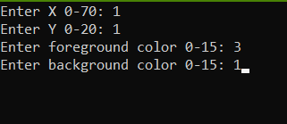
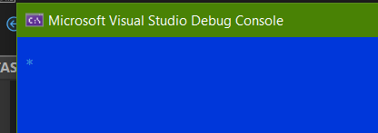

TASK 3

INCLUDE Irvine32.inc

.data
buffer BYTE 100 DUP(0)
msg1 BYTE "Enter X: ", 0
msg2 BYTE "Enter Y: ", 0
msg3 BYTE "Enter foreground color 0-15: ", 0
msg4 BYTE "Enter background color 0-15: ", 0
msg5 BYTE "Enter text: ", 0

.code

main PROC

mov edx, OFFSET msg1
call WriteString
call ReadInt
mov ebx, eax

mov edx, OFFSET msg2
call WriteString
call ReadInt
mov ecx, eax

mov edx, OFFSET msg3
call WriteString
call ReadInt
mov edi, eax

mov edx, OFFSET msg4
call WriteString
call ReadInt
imul eax, 16
add eax, edi
call SetTextColor

mov edx, OFFSET msg5
call WriteString
mov edx, OFFSET buffer
mov ecx, 100
call ReadString

call Clrscr

mov dh, cl
mov dl, bl
call Gotoxy

mov edx, OFFSET buffer
call WriteString

mov eax, 7
call SetTextColor
mov dh, 24
mov dl, 0
call Gotoxy

exit
main ENDP

END main

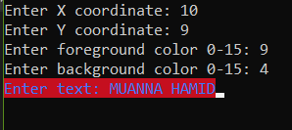
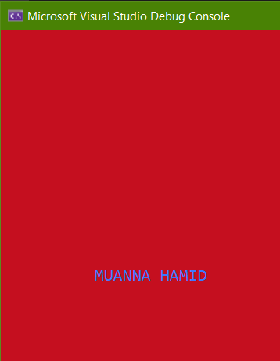

TASK 4:
INCLUDE Irvine32.inc
.data
P_X BYTE "Entr X: ",0
P_Y BYTE "Entr Y: ",0

P_WIDTH BYTE "Enter WIDTH: ",0

P_LENGTH BYTE "Enter LENGTH: ",0

P_BORDER BYTE "BORDER color : ",0

P_FILL BYTE "FillING color",0

x BYTE ?
y BYTE ?

len BYTE ?
wid BYTE ?

fillColor BYTE ?
borderColor BYTE ?

.code
main PROC
mov edx, OFFSET P_X
call WriteString
call ReadInt
mov x, al

mov edx, OFFSET P_Y
call WriteString
call ReadInt
mov y, al

mov edx, OFFSET P_WIDTH
call WriteString
call ReadInt
mov wid, al

mov edx, OFFSET P_LENGTH
call WriteString
call ReadInt
mov len, al

mov edx, OFFSET P_BORDER
call WriteString
call ReadInt
mov borderColor, al

mov edx, OFFSET P_FILL
call WriteString
call ReadInt
mov fillColor, al

call Clrscr

mov dh, y
mov ch, 0

row_loop:
mov dl, x
mov cl, 0

col_loop:
call Gotoxy

; Check if border
cmp ch, 0
je is_border
mov al, ch
inc al
cmp al, len
je is_border
cmp cl, 0
je is_border
mov al, cl
inc al
cmp al, wid
je is_border

mov al, fillColor
jmp draw

is_border:
mov al, borderColor

draw:
call SetTextColor
mov al, 219
call WriteChar

inc dl
inc cl
cmp cl, wid
jl col_loop

inc dh
inc ch
cmp ch, len
jl row_loop

mov eax, 7
call SetTextColor
exit
main ENDP
END main

